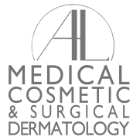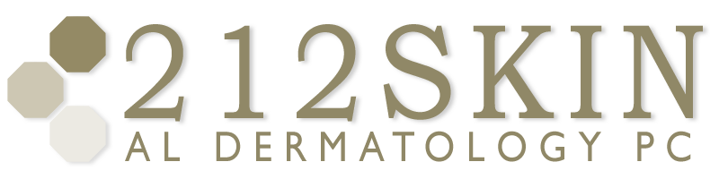
AL DERMATOLOGY PC
LYUBOV AVSHALUMOVA D.O. F.A.O.C.D.
80 BEEKMAN STREET NEW YORK, NY 10038

_____________________________________________________________________________________________
P: (212) 729-SKIN (7546) | F: (212) 729-9395 | Email: contact@212skin.com | www.212SKIN.com

CARE OF LIQUID NITROGREN TREATED SITES

Your ________________________ have been treated with Liquid Nitrogen. This liquid is the same nitrogen that you breathe in the air except it is in a very cold, liquid form. Initially the treated sites will be tender. Within minutes to hours there may be redness, edema (swelling), and early blister formation at the frozen areas. Later on, the formation of crusts and larger blisters are completely normal reactions to this form of therapy and should not be cause for alarm. Blisters may turn color including red, yellow, orange, black or brown, which may represent some leakage of serum and blood into blisters, again a normal reaction.
Note: for some people there is no visible change at the treated sites, i.e.: no crusts nor a blister, which does not mean that the intended results will not occur.

It is of great importance that you give meticulous care to the treated sites so as to prevent infection and to decrease the risk of scarring. You are to apply _________________ Ointment (antibiotic ointment available by prescription / over the counter) to the treated sites several times a day in order to keep the wound well lubricated. Do not allow the area to become “dry”. The use of Band-Aids is encouraged, especially for easily traumatized sites such as hands and feet. The above described wound care should be continued until there is new pink skin entirely covering the treated sites.

Please notify our office immediately with any signs of infection of the treated area(s), including, but not limited to: increased redness or pain, pus or other discharge, or fever. An evaluation by the doctor and an oral antibiotic may be necessary at that time.

