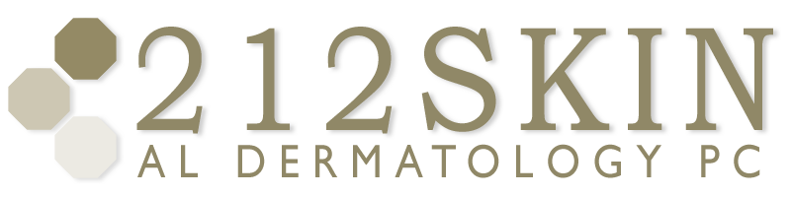
AL DERMATOLOGY PC
LYUBOV AVSHALUMOVA D.O. F.A.O.C.D.
80 BEEKMAN STREET NEW YORK, NY 10038

_____________________________________________________________________________________________
P: (212) 729-SKIN (7546) | F: (212) 729-9395 | Email: contact@212skin.com | www.212SKIN.com
Botox Cosmetic/Therapeutic Post Treatment Care

- Try to exercise your treated muscles 1-2 hours after treatment (e.g. practice frowning, raising your eyebrows or squinting). This helps to work Botox into your muscles. Although his is thought to help, it will NOT impact your treatment.

- Do NOT rub or massage the treated areas for 2 hours after your treatment. Do NOT do strenuous exercise for 4 hours after treatment. Also avoid facials or saunas for 4 hours after your treatment. This will minimize the risk or raising your blood pressure and therefore minimize the risk of temporary bruising. Feel free to shower and go about most other regular daily activities.

- Do NOT lie down 4 hours after treatment. This is to avoid the risk of pressure on the treated areas (from your pillow) and to avoid the risk of having rubbed accidentally.

- Be assured that any time bumps or marks will go away within a few hours. If you need to apply makeup within 4 hours after treatment, only apply makeup gently to avoid rubbing the treated area.

- Results of your treatment may take up to 14 days to take full effect. Please wait until the 13 days has passed before assessing if you are pleased with the result.

- Our office will need to see you for a 2 week follow-up assessment appointment.

- Botox requires a special technique in order to customize the injections to your individual muscular structure, it is important that your muscle activity recovers BUT that your skin is not creasing to the point from where you started.

- Botox is a temporary procedure and at first, you may find that your treatment results will last approximately 3-4 months. If you maintain your treatment appointments with the frequency recommended, the duration of each treatment result may last longer than 4 months.

- Plan to return to our office for a 2 week follow-up assessment.

