AL DERMATOLOGY PC
LYUBOV AVSHALUMOVA D.O. F.A.O.C.D.
WAI PING CHAN, D.O
80 BEEKMAN STREET NEW YORK, NY 10038
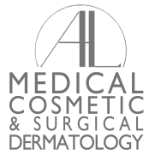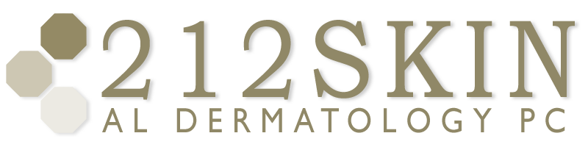

_____________________________________________________________________________________________
P: (212) 729-SKIN (7546) | F: (212) 729-9395 | Email: contact@212skin.com | www.212SKIN.com
POST TREATMENT SKIN CARE INSTRUCTIONS
Apply: Finacea gel Benzaclin gel Metro gel 1% in the Morning.
Aczone gel Clindamycin 1% gel Acanya gel
Clindamycin 1% lotion Duac gel Metro cream 0.75%

*********************************************************************************
Apply: Differin 0.3% gel Tretinoin 0.025% cream/gel at Night.
Tretinoin 0.04% gel Tretinoin 0.05% cream
Tretinoin 0.1% cream/gel Clindamycin 1% gel
Clindamycin 1% lotion Metro cream 0.75%
Metro gel 1%

*********************************************************************************
Wash with: Cetaphil oil control foam wash Once / Twice a day
Cerave cleanser
Benzoyl peroxide wash 6 – 10%
Sodium Sulfacetomide/ Sulfur wash
Dove Hypoallergenic wash
*********************************************************************************
Take oral Doxycycline 75mg Doxycycline 100mg Once / Twice a day
Minocycline 50mg Minocycline 100mg
Solodyn TAB Monodox TAB

For ___________________
********************************************************************************
Moisturize with: Cerave cream/ lotion Amlactin cream Once/ Twice a day
Amlactin lotion Urea 40% cream
Aquaphor ointment Eucerin cream

********************************************************************************

_______________________________ ________________________
PATIENT NAME TODAY’S DATE

_________________________________________
DOCTOR’S SIGNATURE

