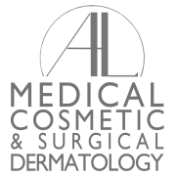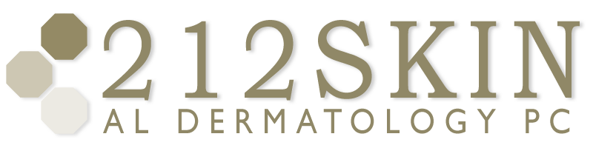
AL DERMATOLOGY PC
LYUBOV AVSHALUMOVA D.O. F.A.O.C.D.
80 BEEKMAN STREET NEW YORK, NY 10038

_____________________________________________________________________________________________
P: (212) 729-SKIN (7546) | F: (212) 729-9395 | Email: contact@212skin.com | www.212SKIN.com

VASCULAR
ICD#________
Name_____________________________ Date: __________

34F | U / A COMPLETE
42A | CBC W/DIFF PLAT
18T | COMPREHENSIVE METABOLIC PANEL
45377W | ESR
249X | ANA
8458T | SSA-SSB (SJORGEN’S ANTOBODY)
10306F | HEP A/B/C SCREEN
142075P | DNASE B (STREPT)
36561A | CRYOGLOBINS (SUNRISE ONLY)
52555P | COLD AGGLUTINIS (SUNRISE ONLY)
4044F | ANCA VASCULIDITES
11343X | PROTEIN S
8754X | PROTEIN C
7079T | LUPUS ANTI-COAGULANT
2790A | ANTI-CARDIO LIPIN (IGG, IGM & IGA)
376X | CRYO FIBROGENS
30340X | B-2 GLYCOPROTEIN IAB (IGG,IGM & IGA)
687T | S-PEP

