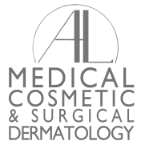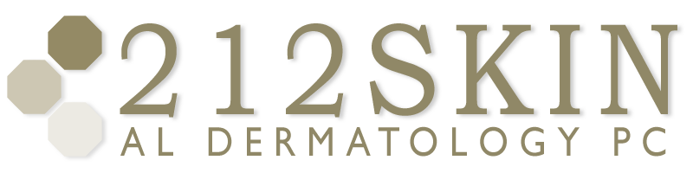
AL DERMATOLOGY PC
LYUBOV AVSHALUMOVA D.O. F.A.O.C.D.
80 BEEKMAN STREET NEW YORK, NY 10038

_____________________________________________________________________________________________
P: (212) 729-SKIN (7546) | F: (212) 729-9395 | Email: contact@212skin.com | www.212SKIN.com

URTICARIA
ICD#L50.1
Name_____________________________ Date: __________

42A | CBC W/DIFF PLAT
10231A | COMPREHENSIVE METABOLIC PANEL
249X | ANA
8458T | SSA-SSB (SJORGEN’S ANTOBODY)
10306F | HEP A/B/C SCREEN
45377W | ESR
115725R | RF (RHEUMATOID FACTOR)
53702E | ANTI-STREPTOLUSIN O ANTIBODY
44859W | C3
44982E | C4
45328W | CH50 FROZEN SPECIMEN
1156F | RPR
53934R | FTA
687T | S-PEP
142075P | DNASE B (STREPT)
653A | LIVER PANEL
43588T | THYROID PANEL
7302A | THYROID AB
30163 | TSH

