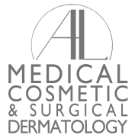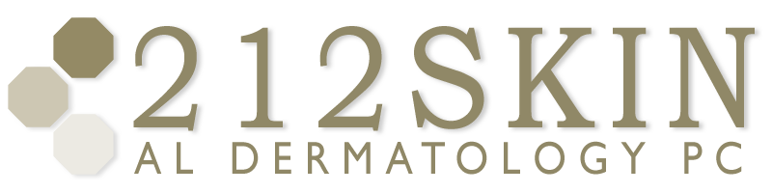
AL DERMATOLOGY PC
LYUBOV AVSHALUMOVA D.O. F.A.O.C.D.
80 BEEKMAN STREET NEW YORK, NY 10038

_____________________________________________________________________________________________
P: (212) 729-SKIN (7546) | F: (212) 729-9395 | Email: contact@212skin.com | www.212SKIN.com
Trigger Factors in Rosacea
Factors | Patient Affected
Sun Exposure | 81%
Emotional Stress | 79%
Hot Weather | 75%
Wind | 57%
Heavy Exercise | 56%
Alcohol Consumption | 52%
Hot Baths | 51%
Cold Weather | 46%
Spicy Foods | 45%
Humidity | 44%
Indoor Heat | 41%
Certain Skincare Products | 41%
Heated Beverages | 36%
Certain Cosmetics | 27%
Medications | 15%
Medical Condition | 15%
Certain Fruits | 13%
Marinated Meats | 10%
Certain Vegetables | 9%
Dairy Products | 8%
Other Factors | 24%

Data from National Rosacea Society.

