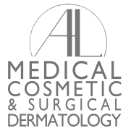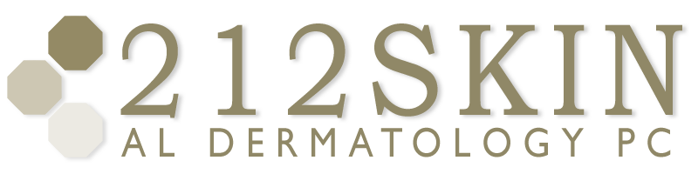
AL DERMATOLOGY PC
LYUBOV AVSHALUMOVA D.O. F.A.O.C.D.
80 BEEKMAN STREET NEW YORK, NY 10038

_____________________________________________________________________________________________
P: (212) 729-SKIN (7546) | F: (212) 729-9395 | Email: contact@212skin.com | www.212SKIN.com

PROPECIA
ICD#L65.4
Name_____________________________ Date: __________

42A | CBC W/DIFF PLAT
18T | COMPREHENSIVE METABOLIC PANEL
968T | LIPID PANEL
28571E | PSA
22434R | ESTRADIOL
36170X | TESTERONE FREE & TOTAL
67751 | DIHYDROTESTOSTERONE

