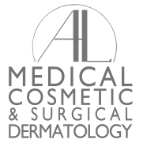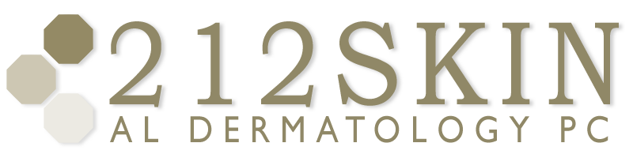
AL DERMATOLOGY PC
LYUBOV AVSHALUMOVA D.O. F.A.O.C.D.
80 BEEKMAN STREET NEW YORK, NY 10038

_____________________________________________________________________________________________
P: (212) 729-SKIN (7546) | F: (212) 729-9395 | Email: contact@212skin.com | www.212SKIN.com

PHOTOSENSITIVITY
ICD#_________
Name_____________________________ Date: __________

42A | CBC W/DIFF PLAT
10231A | COMPREHENSIVE METABOLIC PANEL
249X | ANA
8458T | SSA-SSB (SJORGEN’S ANTIBODY)
66985R | ALDOLASE
21576R | CPK
10289N | PLASMA PORPHYRINS
52340P | ANTI-JO-1-AB

