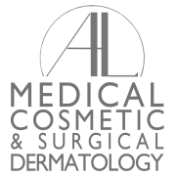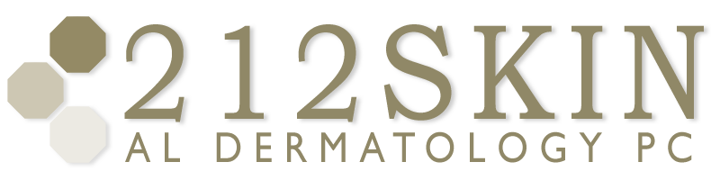
AL DERMATOLOGY PC
LYUBOV AVSHALUMOVA D.O. F.A.O.C.D.
80 BEEKMAN STREET NEW YORK, NY 10038

_____________________________________________________________________________________________
P: (212) 729-SKIN (7546) | F: (212) 729-9395 | Email: contact@212skin.com | www.212SKIN.com

METHOTREXATE
ICD#_________
Name_____________________________ Date: __________

26013E | MAGNESIUM
30841E | URIC ACID
18T | COMP. METABOLIC PANEL
968T | LIPID PROFILE
21576R | CPK
42A | CBC W/DIFF
34F | U/A COMPLETE

