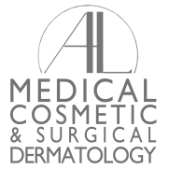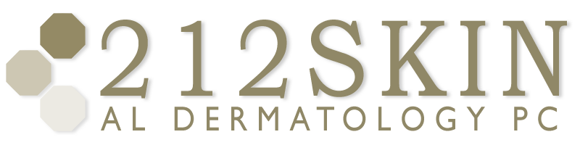
AL DERMATOLOGY PC
LYUBOV AVSHALUMOVA D.O. F.A.O.C.D.
80 BEEKMAN STREET NEW YORK, NY 10038

_____________________________________________________________________________________________
P: (212) 729-SKIN (7546) | F: (212) 729-9395 | Email: contact@212skin.com | www.212SKIN.com
HAIR LOSS DIAGNOSIS CODE: ________________
Name_____________________________ Date: __________
CPT CODES | QUEST CODE | SUNRISE CODE | TEST NAME
84402/84403 | 36170X | 7158 | TOTAL & FREE TESTOSTERONE
82627 | 21915R | 865 | DHEA-S
83002/83001 | 9688T | 3770 | FSH/LH
84443 | 30196E | 38 | TSH
83498 | 17180X | 367 | 17-OH PROGESTERONE
83525 | 15701E | 828 | INSULIN LEVEL
80299 | 67751P | 395 | DIHYDROTESTOSTERONE
82157 | 17182X | 861 | ANDROSTENDIONE
84270 | 30740X | 163 | SEX HORMONE BINDING GLOBULIN
85025 | 42A | 155 | CBC w/DIFF/PLATELETS
80053 | 18T | 2820 | COMPREHENSIVE METABOLIC
82728 | 22764R | 1705 | FERRITIN
86038 | 249X | 500 | ANA
86592 | 1156 | 810 | RPR
84630 | 69732P | 231 | ZINC LEVEL
84590 | 29231E | 278 | VITAMIN A LEVEL
82306 | 17306X | 335 | VITAMIN D LEVEL
*** Please be advised that before these bloods drawn you must confirm with your insurance company, that they will cover blood work for hair loss. Please give us a call if this is a problem. If you decide to have the bloods drawn without checking with your insurance company and they do not cover blood work you will be full responsible for the bill.****
Dr. Lyubov Avshalumova

