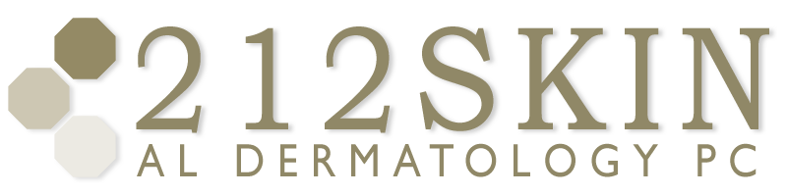
AL DERMATOLOGY PC
LYUBOV AVSHALUMOVA D.O. F.A.O.C.D.
80 BEEKMAN STREET NEW YORK, NY 10038

_____________________________________________________________________________________________
P: (212) 729-SKIN (7546) | F: (212) 729-9395 | Email: contact@212skin.com | www.212SKIN.com

ENDOCRINE
ICD#_________
Name_____________________________ Date: __________
4960 | TOTAL & FREE TESTOSTERONE
21915R | DHEA-S
28423E | PROCLACTIN
57125F | A.M. CORTISOL
9688T | FSH/LH
30502E | T3RU
30163 | TSH
30262E | T4
16691P | 170H PROGESTERONE
7302A | ANTI-THYROID PEROXIDDASE Abs
 | ANTI-THYROGLOBULIN Abs
15701E | INSULIN LEVEL
67751P | DIHYDROTESTOSTERONE 4ml (RED TOP)
18549P | ANDROSTENDIONE
29421P | SEX HORMONE BINDING GLOBULIN
30171P | ANTI TSH RECEPTOR Abs

