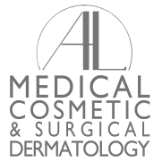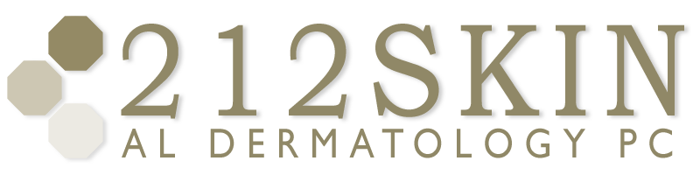
AL DERMATOLOGY PC
LYUBOV AVSHALUMOVA D.O. F.A.O.C.D.
80 BEEKMAN STREET NEW YORK, NY 10038

_____________________________________________________________________________________________
P: (212) 729-SKIN (7546) | F: (212) 729-9395 | Email: contact@212skin.com | www.212SKIN.com

CONNECTIVE TISSUE W/U
ICD#_________
Name_____________________________ Date: __________

42A | CBC w/ DIFF PLAT
10231A | Comprehensive Metabolic Panel
34F | U/A
249X | ANA
8458T | SSA-SSB (SJORGEN’S ANTIBODY)
45377W | ESR
115725R | RF (Rheumatoid Factor)
53702E | ANTI-Streptolysin O Antibody
44859W | C3
44982E | C4
45328W | CH50 Frozen Specimen
1156F | RPR
53934R | FTA
687T | S-PEP
142075P | DNASE B (strept)

