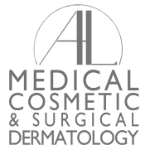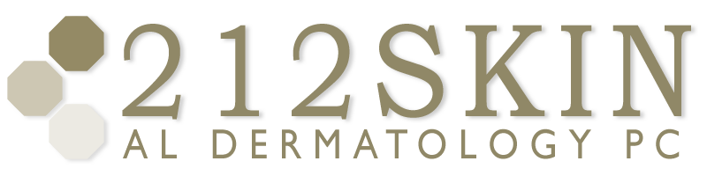
AL DERMATOLOGY PC
LYUBOV AVSHALUMOVA D.O. F.A.O.C.D.
80 BEEKMAN STREET NEW YORK, NY 10038

_____________________________________________________________________________________________
P: (212) 729-SKIN (7546) | F: (212) 729-9395 | Email: contact@212skin.com | www.212SKIN.com

ALOPECIA
ICD #:L65.9
Diagnosis Code: ________________
Name_____________________________ Date: __________

QUEST CODE | SUNRISE CODE | TEST NAME
30262E | 35 | T4
30502E | 37 | T3
42A | 155 | CBC W/DIFF PLATELTES
249X | 500 | ANA
30196E | 35 | TSH
7502 | 5346 | CELIAC PROFILE
18T | 2820 | COMPREHENSIVE METABOLIC PANEL
17306X | 335 | VITAMIN D LEVEL
115725R | 807 | RF
45484R |  | HgBA1C
925F |  | THYROID ANTIBODIES

