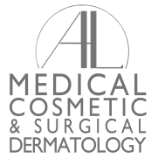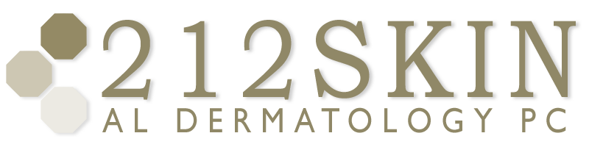
AL DERMATOLOGY PC
LYUBOV AVSHALUMOVA D.O. F.A.O.C.D.
80 BEEKMAN STREET NEW YORK, NY 10038

_____________________________________________________________________________________________
P: (212) 729-SKIN (7546) | F: (212) 729-9395 | Email: contact@212skin.com | www.212SKIN.com

ACCUTANE MALE & FEMALE
ICD #:L70.0

NAME:____________________________ DATE:___________________

42A | CBC w/DIFF PLAT
10231A | Comprehensive metabolic panel
21576r | CPK
21105r | HCG(qualitative) Females Only
968t | Lipid Profile

