AL DERMATOLOGY PC
LYUBOV AVSHALUMOVA D.O. F.A.O.C.D.
80 BEEKMAN STREET NEW YORK, NY 10038
T: (212) 729-SKIN(7546) F: (212) 729-9395 CONTACT@212SKIN.COM | WW.212SKIN.COM
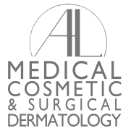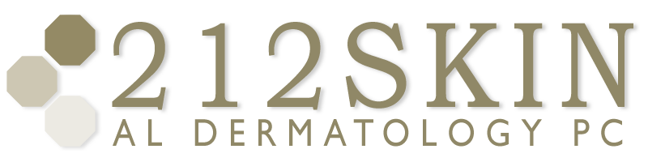

PRIOR AUTHORIZATION
GHI: 800-417-1915 or 212-815-1608

Patient Name: ___________________________________ ____________________________ ________ / ________ / _____________
Last First Date of Birth
Address: _______________________________________ __________________________ _____________ __________________
Street City State ZIP
Insurance Info: __________________________________________ _________________________________________________
Insurance Company Insurance ID
Pharmacy Phone Number:
Prescription in Question:
Prescription Strength:
Prescription Matter: Liquid Gel Tablet
Prior Authorization Insurance Phone Number:
Pharmacist Name:

CASE NUMBER SHOULD BE PROVIDED BY INSURANCE COMPANY ONCE PRIOR AUTHORIZATION BEEN APPROVED OR NOT APPROVED
CASE #

