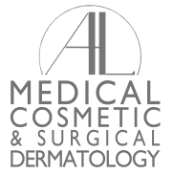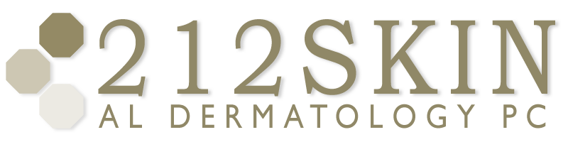
AL DERMATOLOGY PC
LYUBOV AVSHALUMOVA D.O. F.A.O.C.D.
80 BEEKMAN STREET NEW YORK, NY 10038

P: (212) 729-SKIN (7546) | F: (212) 729-9395 | Email: contact@212skin.com | www.212SKIN.com
OPTIONAL COSMETIC INTEREST QUESTIONNAIRE
Patient Name:_________________________________DOB:_________Date:___________

For many people, changes in physical appearance as we age can have a significant impact on self-confidence and even quality of life. Fortunately, today there are many options available to dramatically enhance and improve one’s appearance, and reverse signs of aging.

By letting us know your concerns and preferences, we can help you decide which treatments will offer you the best results.

For the following statements, please circle the number that best reflects your opinion, with
1 as agreeing the least and 5 as agreeing the most.

- If effective, non-surgical options were available to successfully correct my lines and wrinkles, I would be interested.

1 2 3 4 5
- What cosmetic procedures, if any, have you had in the past?
__________________________________________________________________________
- If you have previously had any cosmetic procedures, were you pleased with the outcome?
- Yes
- No
If no, in what way were you dissatisfied?
________________________________________________________________________
Please answer the following questions on a scale of 1 to 5 by circling the appropriate number:
- When looking at my face in the mirror, I believe I look younger, the same as, or older than my true age.

Younger Than True Age Older Than
1 2 3 4 5

- When looking n the mirror, I am not concerned, somewhat concerned, or very concerned about the appearance of my wrinkles.

Not Concerned Somewhat Concerned Very Concerned
1 2 3 4 5

Sometimes the best results can be achieved through different products or procedures by using multiple products or procedures. Please let us know which of the following would interest you. Check all that apply.

□ Dermal fillers such as Restylane®, □ Skin-care advice
Perlane®, Juvederm®, Radiesse®, Belotero®
□ Retin A or Retinol
□ AHA and glycolic peels □ Skin-care products
□ Skin rejuvenation □ Liver spot/age spot correction
□ Laser Treatments □ Birthmark correction
□ Hyperpigmentation □ Sunscreen advice
□ Botox® Cosmetic □ Leg vein correction/Spider Vein Treatment
□ Acne treatment □ Hair Removal
□ Removing facial veins □ Eliminating underarm sweating
□ Lash enhancement □ Chemical peels

□ Other (please specify): __________________________________________________

If our office hosted an event to inform patients about cosmetic procedures, would you be interested in attending?

□ Yes □No

If yes, may we contact you about these events?

□ Yes □No Signature: _______________________________________

How did you hear about our practice?

□ Physician □ Internet
□ Friend of family member □ Yellow pages
□ Seminar □ Advertisement or article (please specify):
□ Insurance company ____________________________________
□ Other (please specify):
____________________________________

If you were referred by one of our patients, please let us know the name so that we may thank him or her: _________________________________________________________________.

With respect to signs of aging, please highlight those areas of the face that bother or trouble you. In the box provided, please rate these areas on a scale of 1 to 5 (1 being least bothersome, 5 being most bothersome).
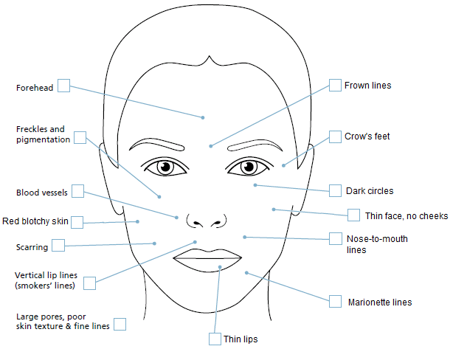

Thank you!

*Comprehensive Cosmetic Consultation with Dr. Avshalumova is $150. If cosmetic procedure is done on the same day as the consultation, the fee will be applied towards the procedure cost.
You may also request a General Cosmetic Consultation with our office manager Sabina free of charge.

80 BEEKMAN ST SOUTHBRIDGE PLAZA “K” NEW YORK, NY 10038
WWW.212SKIN.COM | P: 212-729-SKIN (7546) | P: 212-674-7777 | F: 212-729-9395

