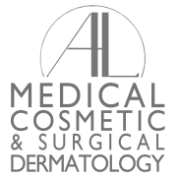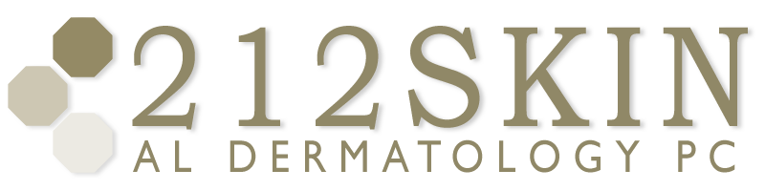
AL DERMATOLOGY PC
LYUBOV AVSHALUMOVA D.O. F.A.O.C.D.
80 BEEKMAN STREET NEW YORK, NY 10038

____________________________________________________________________________________
P: (212) 729-SKIN (7546) | F: (212) 729-9395 | Email: contact@212skin.com | www.212SKIN.com

Date: ____________________

Please Excuse: ____________________________________________________________

From:
- Work
- School
Due To: A dermatological office-visit

Thank you,

Dr. Avshalumova
_________________________________________________

