Medical Assistant________________________ Initials ____ Date_______ Time_____________ NAME:_________________________________ D.O.B. ______________ Date: ______________
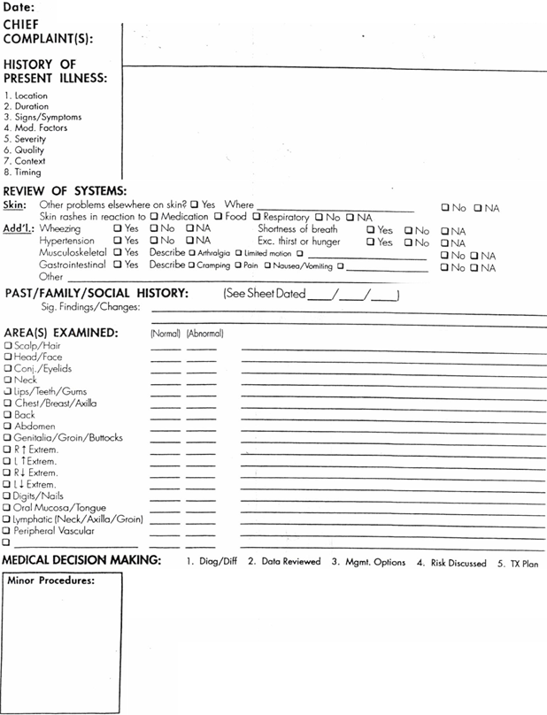

_______________________________________________ _____________
Signature Date
NAME:_________________________________ D.O.B. ______________ Date: ______________

