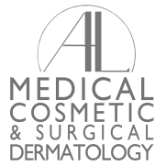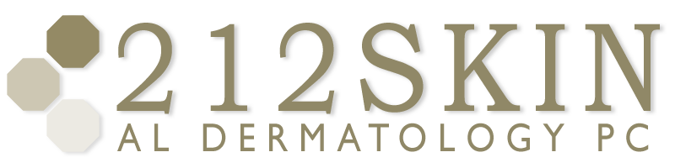
AL DERMATOLOGY PC
LYUBOV AVSHALUMOVA D.O. F.A.O.C.D.
80 BEEKMAN STREET NEW YORK, NY 10038

_____________________________________________________________________________________________
P: (212) 729-SKIN (7546) | F: (212) 729-9395 | Email: contact@212skin.com | www.212SKIN.com
Biopsy Results
Patient Name: ______________________________________________ D.O.B. _____/_____/ _______________
Site: _________________________________________________________________________________________
Results:
Benign Atypical Mole
Precancerous Cancerous
Rash
Recommendations:
No further treatment is necessary at this time. Please call to schedule a follow-up if the mole or spot persists or recurs.
Your biopsy demonstrated a dysplastic nevus (Atypical Mole) which has some irregularity but
considered benign. See Attached Sheet.
Please call to schedule an appointment for the following procedures:
Surgical excision. Your appointment should be scheduled for _____ minutes with
Dr. __________________________________ .
Liquid Nitrogen destruction therapy.
Other: _____________________________________________________________________
___________________________________________________________________________

If additional biopsies of suspicious lesions were recommended, please schedule an appointment in a timely
Fashion as risks may include possible skin cancer.
Please remember that a full complete body examination is advised every 6 to 12 months along with monthly self-examinations. Please return to the office as soon as possible if you have any new or changing moles or spots.
Sincerely,

