212SKIN / AL DERMATOLOGY PC
LYUBOV AVSHALUMOVA D.O. F.A.O.C.D.
80 BEEKMAN STREET NEW YORK, NY 10038

_____________________________________________________________________________________________
P: 212-674-7777 | P: (212) 729-SKIN (7546) | F: (212) 729-9395 | contact@212skin.com | www.212SKIN.com

Request for Payment.

Thank you for choosing 212SKIN Dermatology Center for your healthcare needs. This letter is a payment request for services listed below.

Name: _______________________________________________

Date of Service: ________ / ________ / ____________________

Request for Co-Payment (Was not paid at the time of service) $__________._____

Your insurance company has processed your claim and the
balance is now your responsibility. The outstanding balance is now due. $__________._____
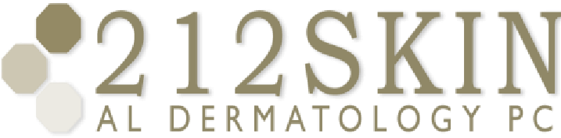

Total: $_________._____

Please pay the amount in full today. If you have questions, please call our Customer Service Department at (212)674-7777 or (212)-729-SKIN (7546).
____________________________________________________________________________________________
P: 212674-7777 | P: (212) 729-SKIN (7546) | F: (212) 729-9395 | contact@212skin.com | www.212SKIN.com

