COSMETIC INTEREST QUESTIONNAIRE
Patient Name: ___________________________________DOB:___________________Date:_________________

We are offering cosmetic treatments. Please let us know your interests and concerns.
□ Dermal fillers such as Restylane®, □ Skin-care advice
Perlane®, Juvederm®, Radiesse®, Belotero® □ Skin-care products
□ Botox® Cosmetic □ Chemical Peels
□ Skin rejuvenation □ Liver spot/age spot correction
□ Laser Treatments □ Hyperpigmentation
□ Laser Hair Removal □ Leg vein correction/Spider Vein Treatment
□ Acne treatment □ Underarm sweating elimination
□ Sunscreen advice □ Medical grade facials
□ Facial vein removal □ Lash enhancement

□ Other (please specify): _______________________________________________________________

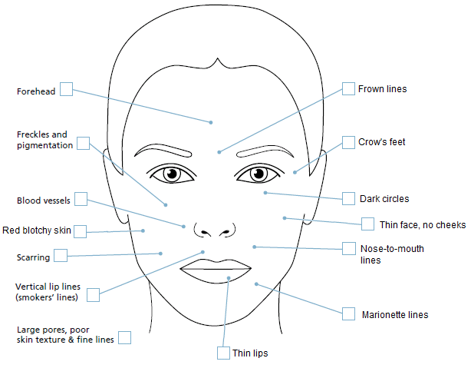
With respect to signs of aging, please highlight those areas of the face that bother or trouble you.

□ I would like to receive promotional email about cosmetic specials. My email _____________________
□ I do not want to receive above mentioned emails.

How did you hear about our practice? _________________________________________________________

Thank you!

